Sensor Tester - PC interface

REV 2.16.03 – 3.1.2019

Roni D.

Content Page

Interface demo image ……………………….. 2

Register map …………………………………. 3

Test string on status window ……………….. 4

Bench test ……………………………………. 6

Setting calibration constants ………………. 7

Serial communication ……………………… 8

Interface demo image

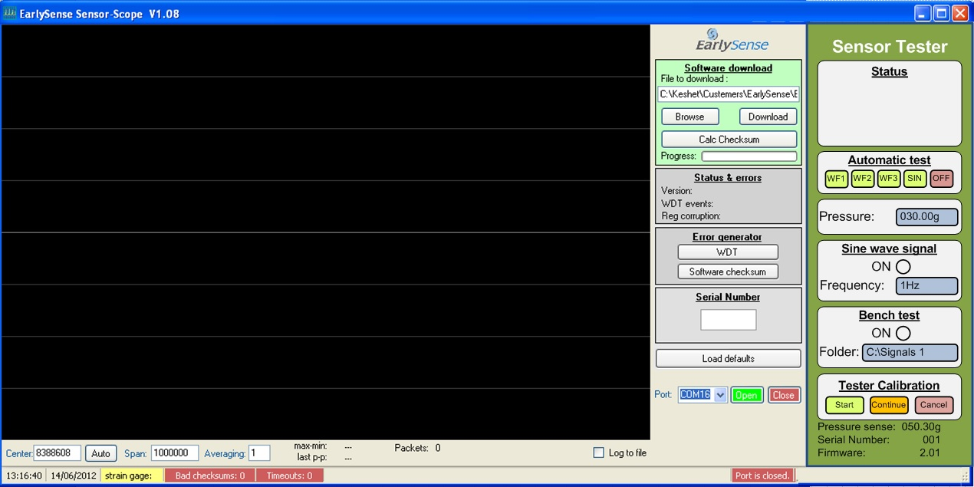

Register map

|  |  |  |  |  |
| --- | --- | --- | --- | --- |
| **Sensor tester MCU memory map - Ram page** | | | | |
| Address | R/W | Bytes | Function | Remarks |
| $2000 | R | 2 | Firmware number | 16 bits. MSB first. Format is 0.00 |
| $2002 | R | 1 | Serial number | 8 bits. Format 000 |
| $2003 | R | 2 | Sense | 16 bits. Format “000.00g” |
| $2005 | R | 1 | Automatic test bar | Graphic progress bar. 0=Empty 255=Full |
| $2006 | R | 1 | Status string | See table below |
| $2007 | R/W | 2 | Frequency | 16 bits. Format “0.0Hz” |
| $2009 | R/W | 2 | Pressure | 16 bits. Format “000.00g” |
| $200B | W | 1 | Key press | Key code is set by the PC. Cleared by the sensor tester.  Code 00 – No operation  Code 01 – Automatic test “SIN” key  Code 02 – Automatic test “OFF” key  Code 03 – Tester calibration “start” key  Code 04 – Tester calibration “Cancel” key  Code 05 - Tester calibration “Continue” key  Code 06 - Automatic test "WF1" key  Code 07 - Automatic test "WF2" key  Code 08 - Automatic test "WF3" key |
| $200C | R/W | 1 | Radio button  Manual operation | Manual operation radio button.  Status is always read from the sensor tester.  Code 00 – Disabled  Code 01 – Enabled |
| $200D | R/W | 1 | Radio button  Bench test | Manual operation radio button.  Status is always read from the sensor tester.  Code 00 – Disabled  Code 01 – Enabled |
| $200E | R | 1 | Buffer busy | Streaming data buffer busy / ready indication  0 = Ready 1 = Busy |
| $200F | R | 1 | Register corruption | 32=OK |
| $2010 | R | 1 | Software checksum | Not in use |
|  |  |  |  |  |
|  |  |  |  |  |
|  |  |  |  |  |
| $2500 | W | 249 | Buffer 0 | Up to 124 samples can be written into this buffer.  Byte 0,1 – Sample 0 (MSB,LSB)  Byte 2,3 – Sample 1 (MSB,LSB)  …  Byte 246,247 – Sample 123 (MSB,LSB)  Byte 248 – Packet ID – 8 bits. Begin with 1. Modulo 255. |

Register map

|  |  |  |  |  |
| --- | --- | --- | --- | --- |
| **Sensor tester MCU memory map - EEprom page** | | | | |
| Address | R/W | Bytes | Function | Remarks |
| $1000 | R | 1 | EE_serial_number |  |
| $1001 | R | 2 | EE_cal_weight_factor |  |
| $1003 | R | 2 | EE_cal_zero_weight |  |
| $1005 | R | 2 | EE_pressure |  |
| $1007 | R/W | 1 | EE_General_gain | 1% per unit. Range 20% to 250% (20 to 250) |
| $1008 | R/W | 1 | EE_16_vs_1_gain | 1% per unit. Range 20% to 250% (20 to 250) |

Text string on status window

The MSB (bit 7) defines the font color.

Bit 7 = 0 / Font color Black

Bit 7 = 1 / Font color Red

Text string is centered on the status window.

|  |  |  |
| --- | --- | --- |
| Code | Status text string | Demo image |
| From PC | Sensor tester  not found. |  |
| 0 | Blank – No text |  |
| 1 | Sine sequence  in progress. |  |
| 2 | Automatic test  completed. |  |
| 3 | Sine wave signal  is active. |  |
| 4 (+128) | Error on test!  Check sensor position,  and Re-start test |  |
| 5 | Calibration step 1:  Place 40g  on sensing area  and press “continue” |  |
| 6 | Calibration step 2:  Place 40g+40g  on sensing area  and press “continue” |  |
| 7 (+128) | Calibration not valid.  Process is canceled |  |
| 8 | Calibration completed successfully |  |
| 9 | Bench test in progress  [File name]  [File number / Total no. of files] |  |
| 10 | Bench test completed | **Status**  Bench test completed |
| 11 | From CSV file |  |
| 12 | From CSV file |  |
| 13 | From CSV file |  |

Bench test

Pressing the bench-test radio button will active the bench-test process.

The PC will stream sample data files, given at “Folder” box, into the sensor tester.

The file order is according to ABC order.

Data pre-streaming processing

The data in the signal file will be processed as following:

1. The data value is divided by 10
2. The average of the signal is subtracted from each value (Removing DC level)
3. If the final value exceeds the range of -22500 to +22500 then an error message will pop-up “Signal amplitude is too high. Bench test stopped”
4. The final result is streamed as a 16 bit integer, 2’th compliment value.

The samples will be grouped into 125 samples per packet, and sent to the sensor tester, via “Write block packet” (See communication on page 7)

The PC software pulls register “Buffer empty”, and sends the data packet whenever this register indicates “Ready” (zero).

Usually, the “Data length” parameter in the write block message (page 7) will be set to 125. However, if less than 125 samples remains to the end of the data file, then the “Data length” parameter will be set to the relevant value.

Streaming the next file

A 1.04 second delay will be initiated after streaming of a data file is completed. The next file will be streamed afterwards. The delay is implemented by streaming of silent data for approximately 1.04 second.

Status window during bench test



The status window will display the followings:

1. Current file name being streamed
2. Progress bar, indicating the streamed bytes relative to the file size
3. Number of file being streamed and the total number of data files in the selected folder
4. Progress bar, indicating the Number of file being streamed relative to the total number of data files in the selected folder.

Bench test termination

Bench test can be terminated by 2 scenarios:

1. Pressing the relevant radio button.
2. The last file in the folder has completed its streaming to the sensor tester. In this case, the sensor tester will turn the “Bench test” radio button automatically, and the PC software does not need to care for that.

Changes for V2.13 10.9.2017

Sensor calibration menu



1. Enter this window by pressing CTRL+SHIFT+E
2. This window shuold be located at the center of the waveform window.
3. The value of the parameters are taken from address $1007, $1008. See page 4 for more details.
4. If parameter editing is desired, then when clicking the relevant text-box - a password window will pop-up under the tester calibration window. (Same window as for the tester calibration).
5. The password is 2984
6. After entering the password, the user can continue to edit the parameter. After hiting "ENTER" the password will no longer be valid.
7. The sensor calibration window should be closed automatically, 60 seconds after the last activity on it. This is regadless of password window open or not. Closing this window will also reset the password entry, if there was any.

Changes for V2.16.02 1.1.2019



1. Change the revision number in the window title to V2.16.02
2. Replace bitmaps "Enabled" and "Disabled" with new ones.
3. Added 3 buttons under the automatic test block.
4. Name change for Key code 01 - Changed from "Active" to "SIN"
5. Name change for Key code 02 - Changed from "Cancel" to "OFF"
6. Added 3 more key codes 06,07,08 - for buttons WF1,WF2,WF3 respectively.
7. Change the "pressure sense" result digits color by the following conditions:  
   If Status string (Address $2006) = 0 or 2 or 8 or 10 then  
    If sense register (Address $2003) is above 47.5g and below 52.5g then  
    Text is Light Green (0,255,0)  
    Else  
    Text is Red (255,0,0)  
    Endif  
   Else  
    Text is Black (0,0,0)  
   Endif

|  |  |  |  |  |
| --- | --- | --- | --- | --- |
| Address | R/W | Bytes | Function | Remarks |
| $200B | W | 1 | Key press | Key code is set by the PC. Cleared by the sensor tester.  Code 00 – No operation  Code 01 – Automatic test “SIN” key  Code 02 – Automatic test “OFF” key  Code 03 – Tester calibration “start” key  Code 04 – Tester calibration “Cancel” key  Code 05 - Tester calibration “Continue” key  Code 06 - Automatic test "WF1" key  Code 07 - Automatic test "WF2" key  Code 08 - Automatic test "WF3" key |

1. Change text string #1 to "Sine sequence in progress" - see page 5 for the layout.

Add test strings 11,12,13 - see page 6Changes for V2.16.03 3.1.2019

1) Replace the bitmaps

2) Use CSV file to print text on the 3 waveform buttons. See CSV file example below.

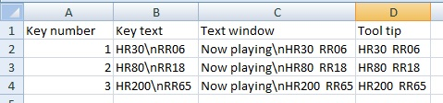

3) The text on the buttons should be very small, as seen on the example below.

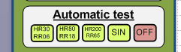

4) Use the CSV table to replace text strings from register $2006, name " Status string", for text string 11,12 and 13. See table on page 6

5) Add button tool tip according to the CSV file.

6) Change revision number to 2.16.03

1. Serial communication

### General

The External system (such as PC terminal) master, and the micro-controller (known as target) will only “answer” to the master demands. In general, the control of the external devices (PC or hand-held) over the system is implemented by reading or writing strings, targeting addresses in the micro-controller memory map. Each address has a different functionality, like range setting, configuration, voltage monitoring, and others.

# Communication specifications

|  |  |
| --- | --- |
| Parameter | Value |
| Port | Serial COM port implemented by USB Bridge CP2102 |
| USB identification | Serial number: 0002  Product string: EarlySense Sensor Tester |
| Protocol | RS232 |
| Baud rate | 256000bps, 1 start bit, 1 stop bit |
| Packet | 15 bytes on packet. Read every 100ms. |
| Max. byte-to-byte interval from PC to Tester | 200ms.  A longer interval will be interpreted as a new command. |
| Tester reply delay | 30mSEC Max. |
| Max. byte-to-byte interval from Tester to PC | 0.1mSEC Max. |

Reading parameter

Read string request packet

Byte 1: start byte code, with the value of ‘R’ (82)

Byte 2,3: 16bit address (msb first)

Byte 4: Data length (n = 1-255)

Byte 5: Normal 8 bit check sum (8 lsb)

Read string respond packet

Byte 1: start byte code, with the value of ‘R’ (82)

Byte 2…2+n: data bytes, according to the data length

Byte 3+n: Normal 8 bit check sum (8 lsb)

Writing parameter

# Write byte packet

Byte 1: start byte code, with the value of ‘W’ (87)

Byte 2,3: 16bit address (msb first)

Byte 4: byte data

Byte 5: Normal 8 bit check sum (8 lsb)

# Write acknowledge

Byte 1:Ack code ‘W’ (87) – must be monitored by PC before sending the next read/write command

# Write block packet

Byte 1: start byte code, with the value of ‘B’ (66)

Byte 2,3: 16bit address (msb first)

Byte 4: Data length (n = 1-255)

Byte 5…5+n: Data bytes

Byte 6+n: Normal 8 bit check sum (8 lsb)

# Block acknowledge

Byte 1:Ack code ‘W’ (87) – must be monitored by PC before sending the next read/write command

# Check-sum error

Error code ‘E’ (69) will be received for check-sum error. Error code will not be transmitted if **echo** option is enable.

## Packet time out error

If byte-to-byte interval is longer than 200mSEC, then the packet is ignored by the target. No “Ack” byte will be send.

## Retry and data correction

Packet-sending retry, and data correction, are all at the responsibility of the master device.